**Exercise No 8: TraceRoute, ping, ifconfig, ipconfig, netstat**

**Aim:**

Using TraceRoute, ping, ifconfig(LINUX), ipconfig(WINDOWS), and netstat

**Command.**

Procedure:

Step 1: open windows command prompt and Type tracert command and type tracert

[www.saveetha.com](http://www.saveetha.com/) -> “Enter”

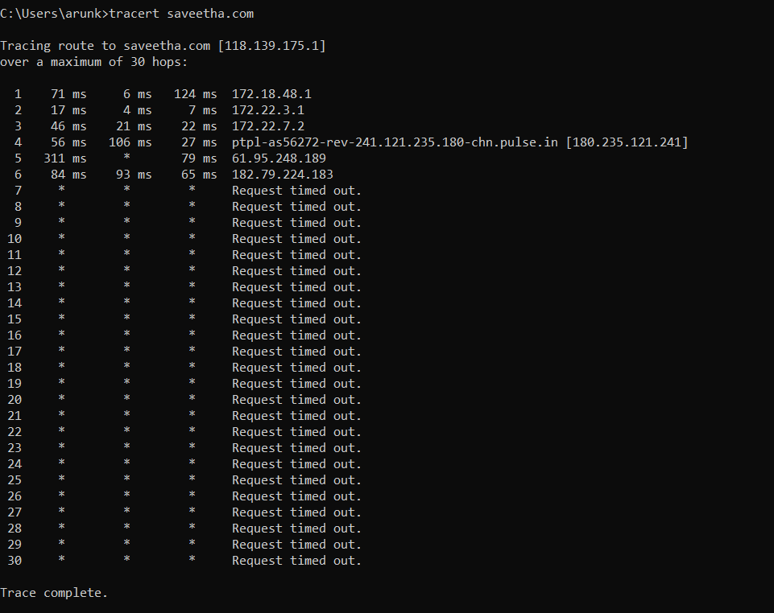

Step 2: Type ping command and type IP Address press “Enter”

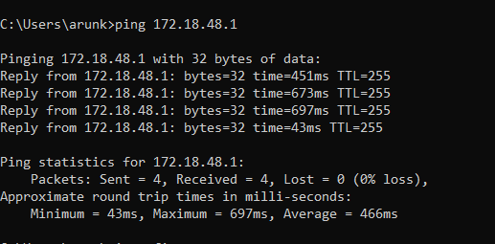

Step 3: Type ifconfig command

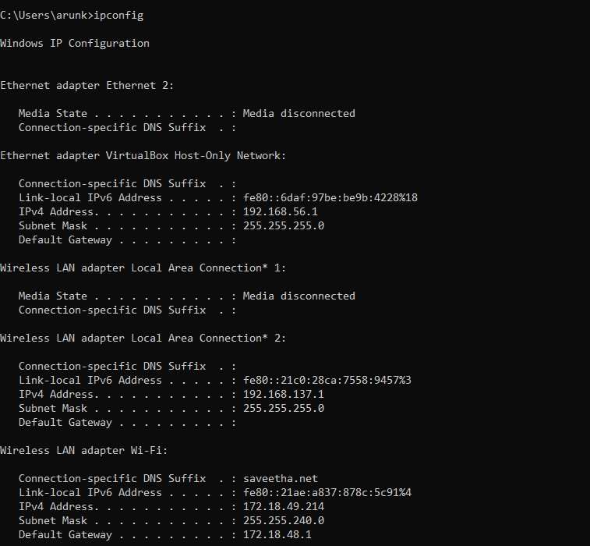

Step 4: Type netstat command

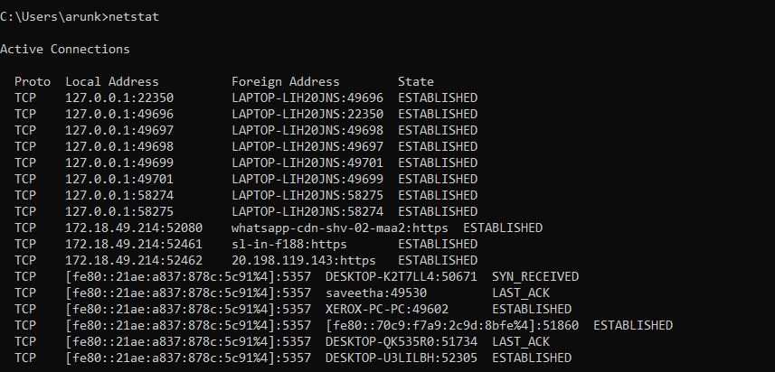

**Result**

Hence the Traceroute, ping , ipconfig (LINUX), ipconfig(WINDOWS) and netstat command executed successfully.